CS403/503 Programming Languages
Spring 2025
Assignment #1

- Problem #3 (i.e., #3 of the Problem Set) of Chapter 3 on Page 157
Answer:
<assign> → <id> = <expr>
<id> → A | B | C
<expr> → <expr > * <term> | <term>
<term> → <factor> + <term> | <factor>
<factor> → ( <expr> ) | <id>

- Problem #8 of Chapter 3 on Page 158
Answer:
To prove this grammar is ambiguous we find a string that has more than one distinct parse tree. A suitable candidate is “a + b + c”.
Left-associative grouping:
<A> <A> + <A>
<A> (<A> + <A>) + <A>
<A> (a + b) + c
Right-associative grouping:
<A> <A> + <A>
<A> <A> + (<A> + <A>)
<A> a + (b + c)
Since both derivations lead to different parse trees, the grammar does not enforce a unique structure for the same string.

- Problem #20 of Chapter 3 on Page 159
Answer:
1. Syntax rule: <assign> → <id> = <expr>
Semantic rule: <expr>.expected_type ← <id>.actual_type

2. Syntax rule: <expr> → <id> + <expr>
Semantic rule:
<expr>.actual_type ← if (<id>.actual_type = int) and (<expr>.actual_type = int) then int else real end if
Predicate: <expr>.actual_type == <expr>.expected_type

3. Syntax rule: <expr> → <id> * <expr>
Semantic rule:
<expr>.actual_type ← if (<id>.actual_type = int) and (<expr>.actual_type = int) then int else real end if
Predicate: <expr>.actual_type == <expr>.expected_type

4. Syntax rule: <expr> → ( <expr> )
Semantic rule: <expr>.actual_type ← <expr>.actual_type
Predicate: <expr>.actual_type == <expr>.expected_type

5. Syntax rule: <expr> → <id>
Semantic rule: <expr>.actual_type ← <id>.actual_type
Predicate: <expr>.actual_type == <expr>.expected_type

6. Syntax rule: <id> → A | B | C
Semantic rule: <id>.actual_type ← look-up(<id>.string)

- Problem #7 of Chapter 4 on Page 194
Answer:
Consider the traditional grammar for arithmetic expressions that follows:
1. E → E + T
2. E → T
3. T → T * F
4. T → F
5. F → (E)
6. F → id

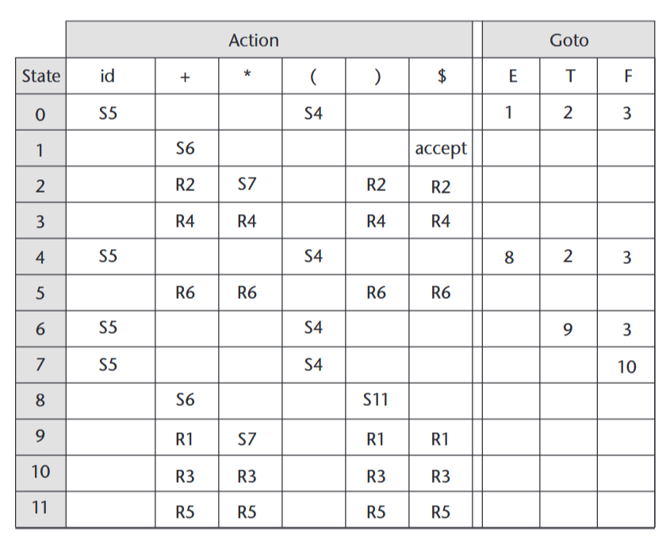
String: id * (id + id)
Stack | Input | Action
0 | id * (id + id)$ | Shift 5
0id5 | * (id + id)$ | Reduce 6 [0, F]
0F3 | * (id + id)$ | Reduce 4 [0, T]
0T2 | * (id + id)$ | Shift 7
0T2*7 | (id + id)$ | Shift 4
0T2*7(4 | id + id)$ | Shift 5
0T2*7(4id5 | + id)$ | Reduce 6 [4, F]
0T2*7(4F3 | + id)$ | Reduce 4 [4, T]
0T2*7(4T2 | + id)$ | Reduce 2 [4, E]
0T2*7(4E8 | + id)$ | Shift 6
0T2*7(4E8+6 | id)$ | Shift 5
0T2*7(4E8+6id5 | )$ | Reduce 6 [6, F]
0T2*7(4E8+6F3 | )$ | Reduce 4 [6, T]
0T2*7(4E8+6T9 | )$ | Reduce 1 [4, E]
0T2*7(4E8 | )$ | Shift 11
0T2*7(4E8)11 | $ | Reduce 5 [7, F]
0T2*7F10 | $ | Reduce 3 [0, T]
0T2 | $ | Reduce 2 [0, E]
0E1 | $ | accept

